**MINI PROJECT**

Name: Chengalva Sai Harikha

1)Creating and activating the database



2,3)Creating Tables

Database Diagram

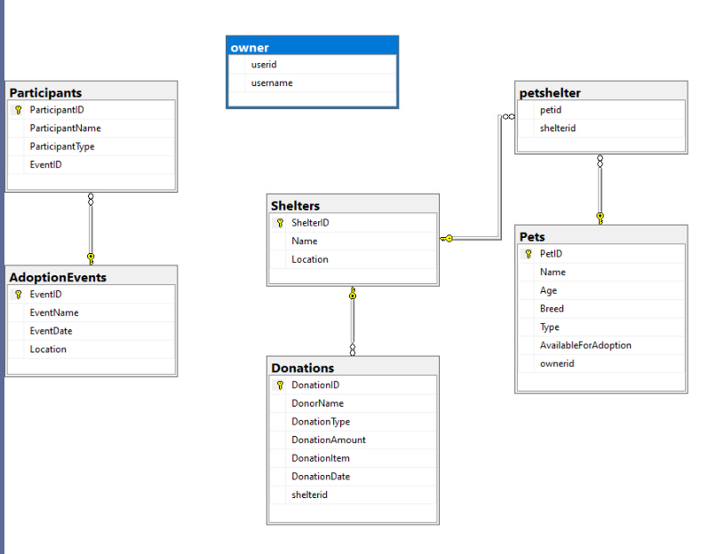

4)

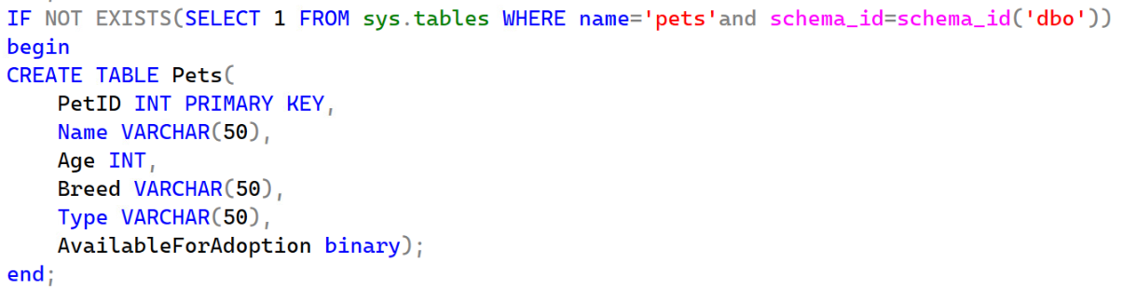

**INSERTING DATA**

Pets

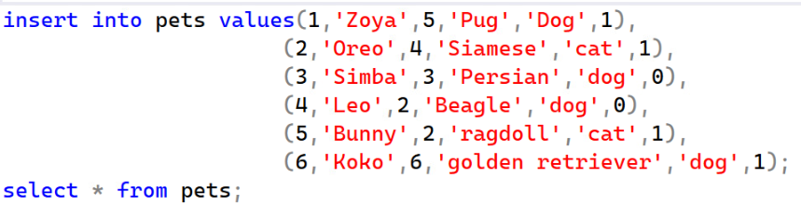

Shelters

Donation

AdoptionEvents

Participants

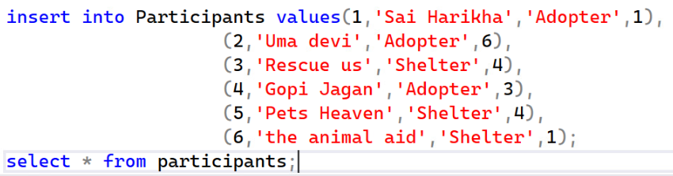

5)

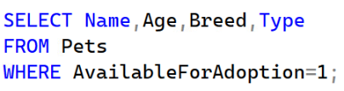

6) 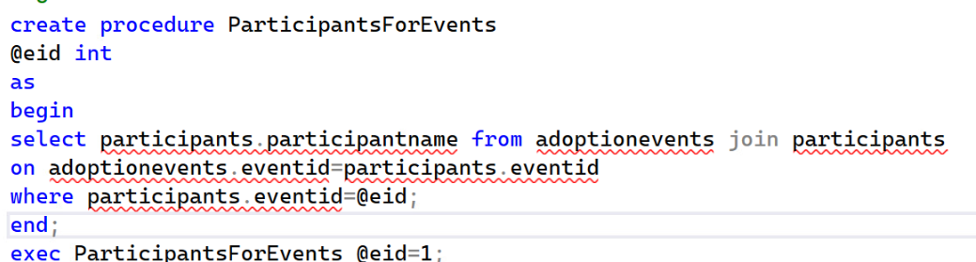

7)

) 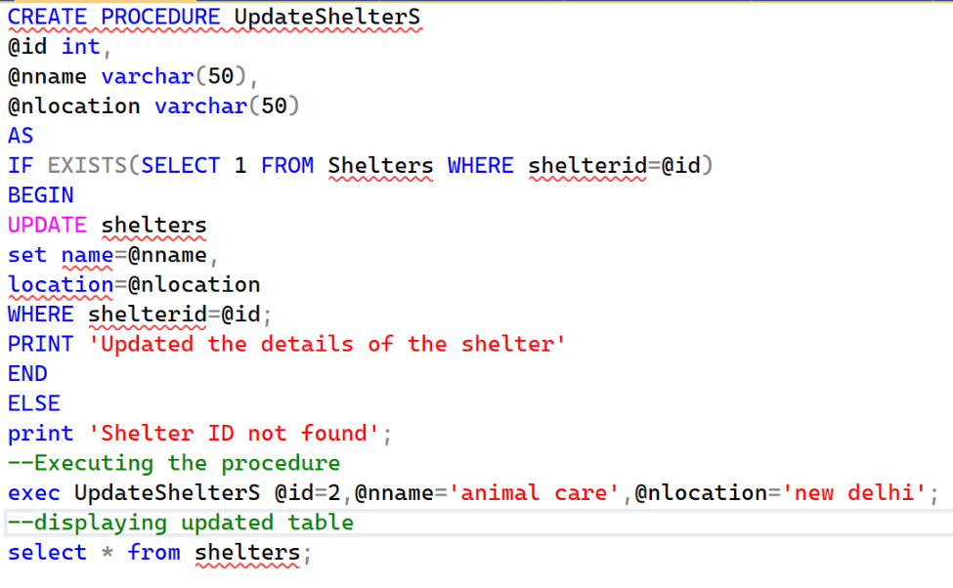

8)

9)altered table pets to include column ownerid

Table after altering

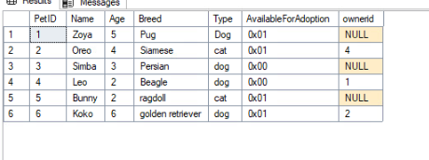

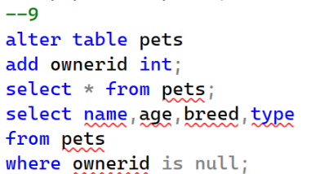

**10)** 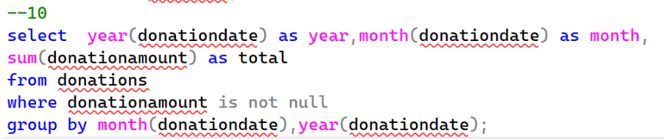

**11)**

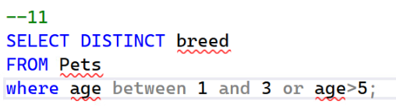

12)

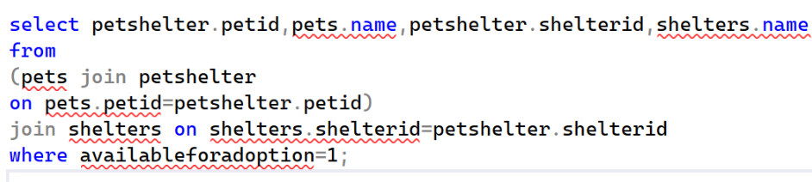

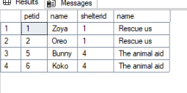

13)

14)

15)

16)

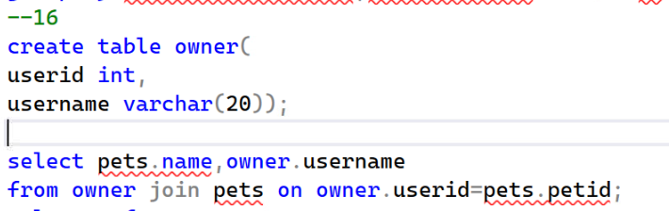

17) 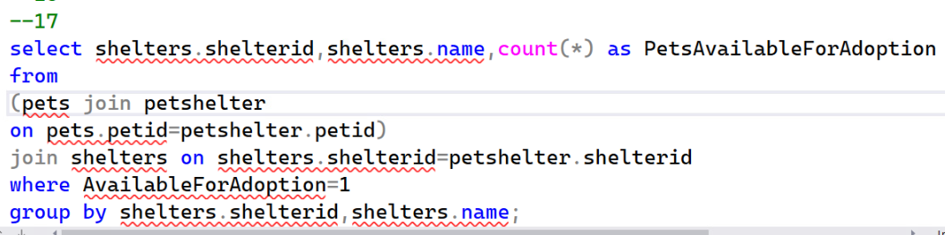

18)

19)

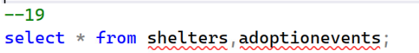

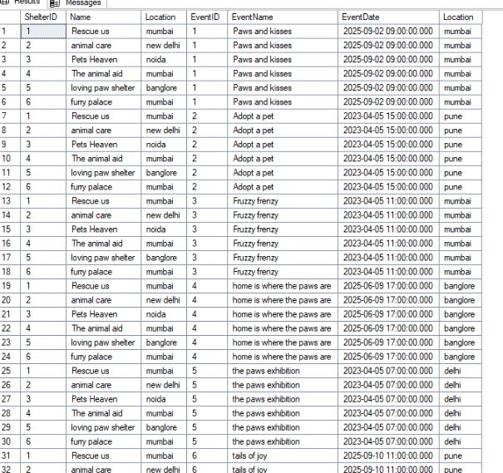

20)



